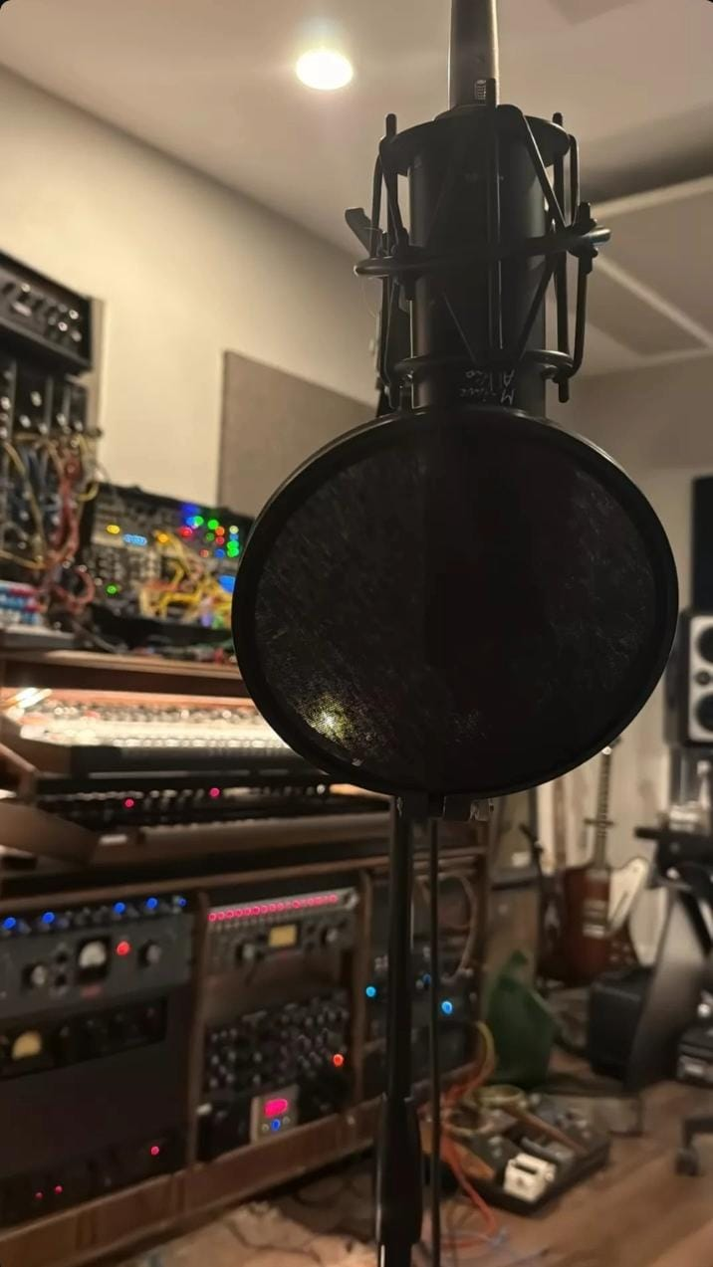
WEDE
WEB PROPOSAL 2
taariq ismail
2026
INDEX:

- Organisation Overview | 2
- Website Goals and Objectives | 2 - 3
- Current Website Analysis | 3
- Proposed Website Features and Functionality | 3 - 4
- Design and User Experience | 4
- Technical Requirements | 4
- Timelines and Milestones | 5
- Budget | 5
- References | 5

Website Project Proposal 2

Target Organisation: Riqo’s Production

1. Organisation Overview

Name: Riqo’s Production

Riqo’s Production is an independent music production brand founded by Taariq Ismail. The brand focuses on producing instrumentals and beats for artists within hip-hop, trap, and modern digital music genres.

The purpose of Riqo’s Production is to provide artists with high-quality beats and music production services that help them create professional and unique music projects. The production brand works with independent artists and content creators who require instrumentals for their music.

Currently, the brand connects with artists primarily through social media and direct communication. However, there is no dedicated website where artists can learn about the services offered or contact the producer professionally.

Developing a website will allow Riqo’s Production to present its services in a structured and professional manner, making it easier for artists to discover the brand and enquire about collaborations.

Mission Statement:

The mission of Riqo’s Production is to produce high-quality beats and instrumentals that support artists in creating original music.

Vision Statement:

The vision of Riqo’s Production is to grow into a recognised music production brand that collaborates with artists locally and internationally.

Target Audience:

The target audience includes:

- Independent rappers and vocalists

- Music artists searching for beats

- Content creators who need background music

- Individuals interested in music production

2. Website Goals and Objectives

The main goal of the website is to create a professional platform where artists can learn about the services offered by Riqo’s Production.

Objectives include:

- Promoting music and video production services

- Presenting available beats and production work

- Creative direction

- Allowing artists to enquire about collaborations

- Building a professional online identity for the brand

Key Performance Indicators (KPIs):

- Portfolio Views
- Measure how many users view the music production portfolio or beats
- User Interaction
- Track how many users click on audio samples, videos, or contact sections
- Website Accessibility
- Ensure the site works properly on phones, tablets, and computers
- Navigation Efficiency
- Users should easily find pages like beats, services, and contact information
- Contact Requests
- Measure how many users reach out through the contact page for collaborations or services

3. Current Website Analysis

Currently, Riqo’s Production operates mainly through social media and personal communication with artists.

Strengths:

Direct communication with artists

Weaknesses:

- No official website

- Limited structured presentation of services

Areas for Improvement:

Creating a website will provide a professional platform where artists can learn about services and contact the producer easily.

4. Proposed Website Features and Functionality

The website will include the following pages:

- Homepage (index.html)
Introduction to the producer and overview of services.

- About Page (about.html)
Information about the producer, founder, and production style.

- Services Page (services.html)
Details about beat production and collaboration services.

- Enquiry Page (enquiry.html)
A form where artists can enquire about purchasing beats or working together.

- Contact Page (contact.html)
Contact details and social media links.

5. Design and User Experience

Colour Scheme

Black - black

Red - red

White - white

These colours represent creativity and modern music culture.

Typography

Bold modern fonts will be used for headings, while body text will use simple sans-serif fonts for readability.

Layout and Design

The website will have a clean and modern layout with clearly organised sections.

User Experience Considerations

- Simple navigation menu

- Clear service information

- Fast loading pages

Sitemap

Home Page
│
├── About riqos production
├── view our services
├── Enquire
└── Contact Page

6. Technical Requirements

The website will be developed using HTML to demonstrate the fundamental structure of web pages.

The project will require a domain name and basic web hosting services.

7. Timelines and Milestones

Week 1 – Project planning and proposal development
Week 2 – Content research
Week 3 – Sitemap and website structure planning
Week 4 – HTML development
Week 5 – Testing and debugging

8. Budget

Domain registration: R150 per year (these are planned domains)
Web hosting: R1,000 per year
Website development: R4,500 once-off
Maintenance: R800 per year

Estimated total: R6,450

9. References

GitHub, 2024. GitHub Documentation. Available at: https://docs.github.com (Accessed: 9 March 2026).
Krug, S., 2014. Don’t Make Me Think: A Common Sense Approach to Web Usability. 3rd ed. Berkeley: New Riders.
Mozilla Developer Network, 2024. HTML: HyperText Markup Language. Available at: https://developer.mozilla.org/en-US/docs/Web/HTML⁠ (Accessed: 9 March 2026).
OpenAI, 2026. ChatGPT (Large Language Model). Available at: https://chat.openai.com (Accessed: 9 March 2026).
W3Schools, 2024. HTML Tutorial. Available at: https://www.w3schools.com/html/⁠ (Accessed: 9 March 2026).
Figures
Figure 1: Riqo’s Production (Ismail, 2026).
Figure 2: Riqo’s Production Studio Image (Ismail, 2026).
Figure 3: Riqo’s Production Promo Video (Ismail, 2026).
Figure 4: Riqo’s Production Mic (Ismail, 2026).
Declaration of AI Assistance
AI-assisted tools such as ChatGPT were used to assist with drafting and structuring the proposal content. All project decisions, development, and final edits were completed independently by Taariq Ismail.

